Lab report 04


CSE 402L
Digital Signal Processing Fall 2024

Submitted by: Naveed Ahmad
Registration No.: 22PWCSE2165
Class Section: B
Semester :5th

“On my honor , as student of University of Engineering and Technology, I have neither given nor received unauthorized assistance on this academic work”

Student Signature: ____________

Submitted to:
Dr. Yasir Saleem Afridi

Nov. 25, 2024

Department of Computer Systems Engineering
University of Engineering and Technology Peshawar

Task:
Will generate the signal of different frequencies say , 10,20,30,40,50,60 Hz (one second duration) using Matlab as shown in figure 1 and transform the same signal in frequency domain using Fourier transform and will compare the frequencies with the time domain signal as shown in figure 2.
Code:
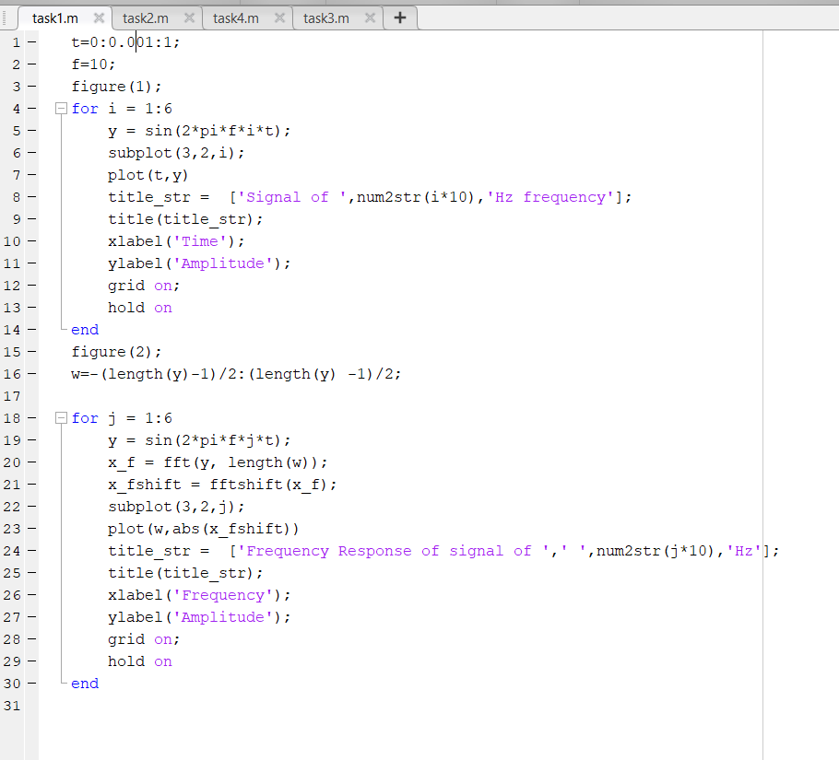
- Time vector t defined, representing time from 0 to 1.
- Base frequency f set as 10 Hz.
- Figure 1 displays sine waves of increasing frequencies.
- Each subplot shows a signal's time-domain representation.
- Figure 2 analyzes and plots frequency-domain responses.
- Frequency vector w defined for FFT centering.
- FFT calculates and plots signal magnitude spectrums.
Output:
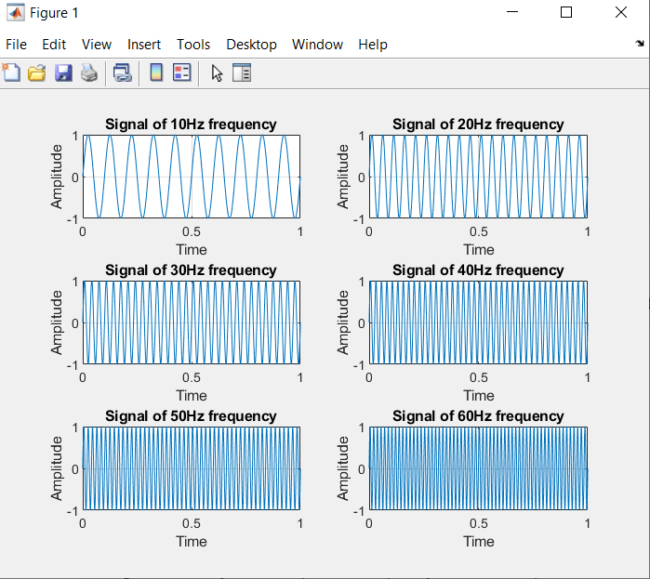
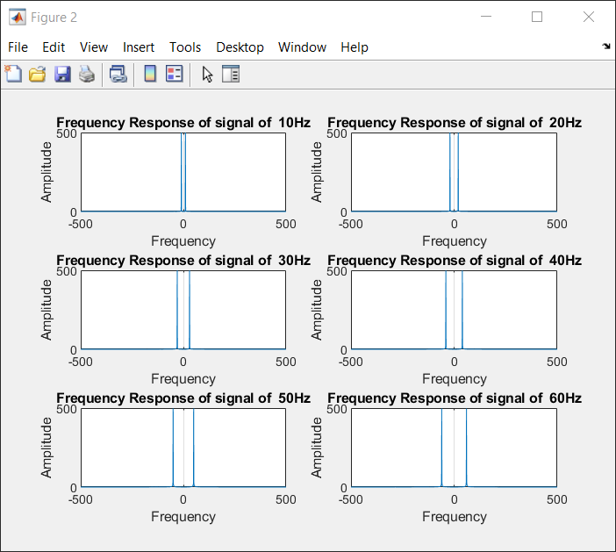
Task 02:
- Compare the Figures 1 and 2 (Generated by your code)
- Add all the signals generated in step 1 and get a composite signal. (which may be considered as a voice signal)
- Plot the time and frequency domain representation of the composite signal as shown in Figure 3
Code:
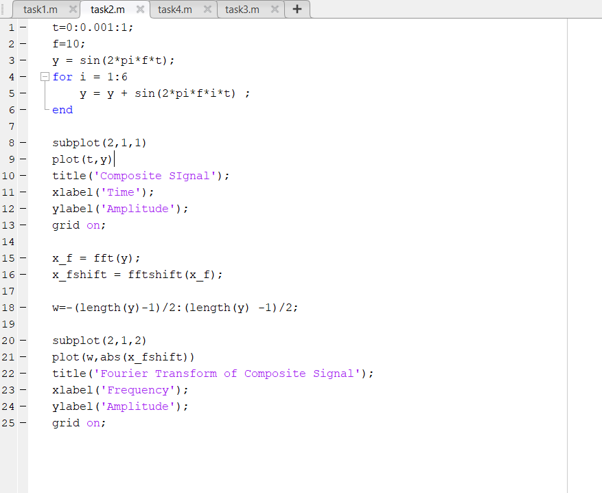
- Time vector t defined from 0 to 1 with 0.001 step size.
- Base frequency f set as 10 Hz.
- Initial sine wave y defined for base frequency.
- Loop adds harmonics to create a composite signal.
- First subplot plots the composite signal in the time domain.
- Title, labels, and grid added for clarity.
- FFT applied to composite signal to analyze frequency domain.
- Frequency vector w defined for centered spectrum.
- Second subplot plots magnitude of Fourier Transform.
Output:
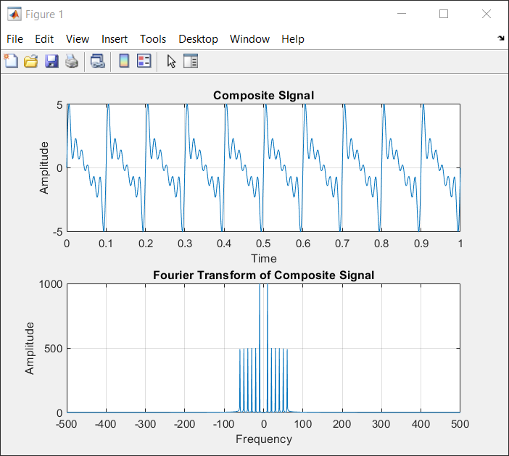
Task 03:
- Compare/Confirm that you are getting all the frequency generated in step 1 above.
- Generate some unwanted signal having frequencies say 80Hz and 100Hz (assume these signals represent noise) and different amplitudes say 0.5 and 0.7
- Obtain both time and frequency representation of noise and confirm they have different power as shown in Figure 4

Code:
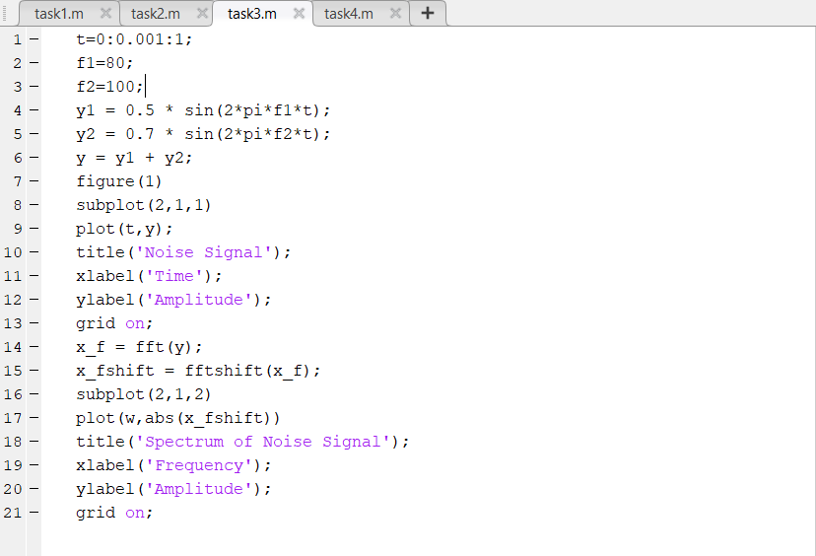

- Time vector t defined from 0 to 1.
- Frequencies f1 (80 Hz) and f2 (100 Hz) defined.
- Signals y1 and y2 generated with respective amplitudes.
- Composite noise signal y created by adding y1 and y2.
- First subplot plots the time-domain noise signal.
- FFT applied to analyze frequency content.
- Frequency spectrum of noise signal plotted in second subplot.

Output:
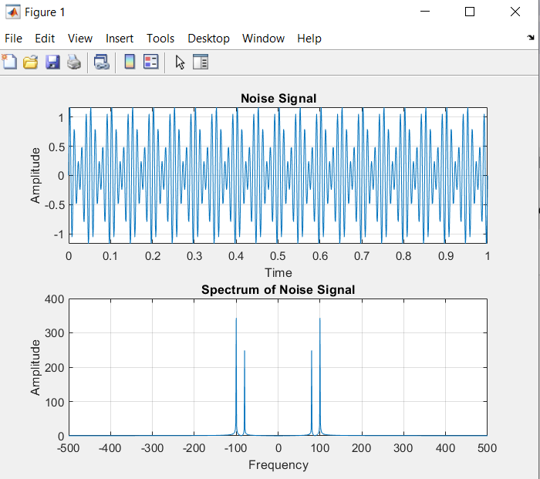

Task 04:
Add the noise to the composite signal (assume the noise is added to the signal during transmission) and obtain frequency spectrum.
Code:
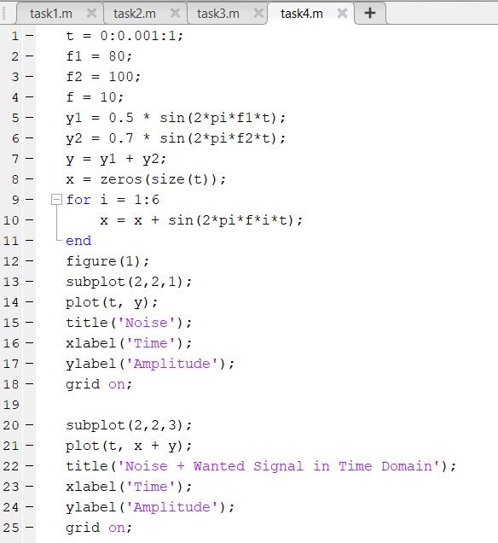
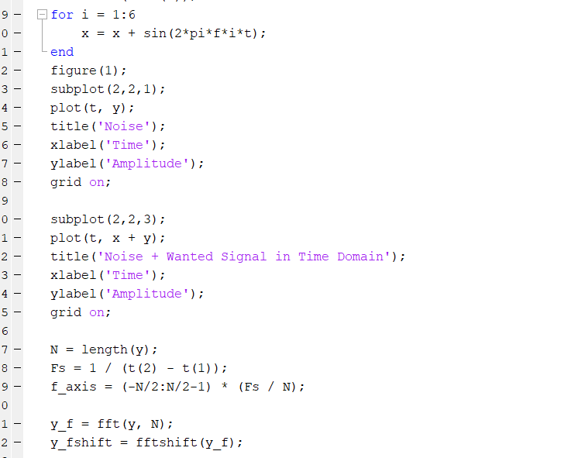
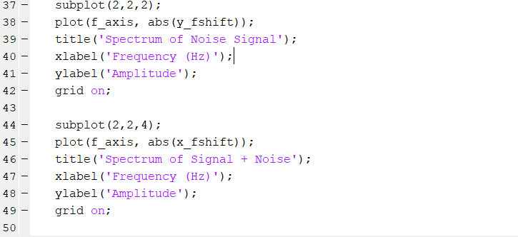
- Time vector t defined from 0 to 1.
- Frequencies f1 (80 Hz) and f2 (100 Hz) set, and base frequency f (10 Hz) defined.
- Signals y1 and y2 created for noise, then combined into y.
- Signal x created by summing sine waves of base frequency f.
- First subplot shows the noise signal in time domain.
- Second subplot shows the combined signal (noise + wanted signal) in time domain.
- FFT applied to both noise and combined signal for frequency analysis.
- Frequency axis f_axis calculated based on signal length and sampling rate.
- Third subplot shows the frequency spectrum of the noise signal.
- Fourth subplot shows the frequency spectrum of the combined signal (noise + wanted signal).
Output:
